A MINI PROJECT

ON

WEATHER APP

Table of Contents
1.INTRODUCTION 3
1.1Key features of weather application 3
2. OBJECTIVE 3
3. Technologies used 4
4. System architecture 4
5. Working process 4
6. Flow Diagram 5
7.Implentation(code) 5
8. Advantages 6
9. Limitations 6
10. Conclusion 6
11. References 6

1.INTRODUCTION

The weather app is a web-based application designed to provide real-time weather information for any location. It allows users to check current weather conditions such as temperatures humidity wind speed and weather forecasts.

This application uses external APIs to fetch live weather data and displays it in a user-friendly interface.

1.1Key features of weather application
- Real-time data: Offers up to the minute information on weather conditions.
- Forecasting: Provides hourly daily and weekly forecasts to assist in planning events or travel.
- Location tracking: Utilizes GPs to automatically detect user location alongside manual search options for other cities.
- API integration: Commonly uses services like open weather map to fetch data.
- User interface (UI): Features an easy-to-use interface often developed with Html, CSS and JavaScript frameworks like Flutter/native android for displaying visual weather details.

2. OBJECTIVE
The main objectives of weather app are:
- To developed a responsive weather application.
- To provide accurate real-time weather updates.
- To allow users to search weather by city or current location.
- To enhanced user experience with attractive UI design.
- Ensures public safety.
- Enhance daily decision-making.
- Optimize user experience.
- Provide real time accuracy.
- Facilitate short term or long-term planning.

3. Technologies used
The project uses the following web technologies:
- HTML (Hypertext Markup Language): Provide the structure of the weather app.
- CSS (cascading Styles Sheets): Enhance the visual appearance of the weather app through styling and layout.
- JavaScript: Adds functionality and API handling.
- Weather API: Fetch real time weather data.

4. System architecture
The system follows a simple architecture:
User--- Input location---API request---Data processing---UI Display
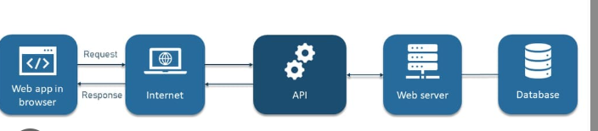
Figure4.1: System Architecture flow diagram

5. Working process
- User enters city name or allows location access.
- Application sends request to weather API.
- API returns weather data in JSON format.
- JavaScript processes the data.
- Weather details are displayed on the screen.

6. Flow Diagram
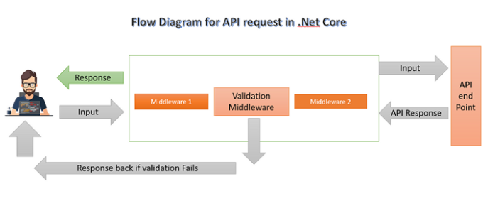
Figure 6.1 User flow diagram
Process explanation:
- User input validation
- Api request formulation
- Api request (HTTP GET)
- Receive and parse data
- Handle response
To fetch weather data, validate the user-inputted city name (Example ensuring it's not empty/numeric) and send a GET request using fetch or Axios with an API key.

7.Implentation(code)
HTML Code:
HTML Is used to create the layout and structure weather app.
- Creates input box (for city name)
- Creates buttons (Search)
- Displays weather data (temperature humidity).
CSS Code:
CSS makes weather app beautiful and attractive.
- Adds colours
- Creates layout (centre spacing)
- Adds background (sky gradient clouds)
- Makes app responsive (mobile-friendly)
JavaScript code:
JavaScript makes the app smart and interactive.
- Takes user input (city name)
- Calls weather API
- Fetches real-time data
- Updates the UI dynamically

8. Advantages
- Easy to use interface
- Real-time data updates
- Lightweight and fast
- Accessible from anywhere
- Hyper local Forecasting
- Personalization

9. Limitations
- Accuracy Issues
- Lack of context
- Dependency on data source
- Requires internet connection
- Privacy concerns

10. Conclusion
The Weather App is a simple yet powerful application that demonstrates the use of APIs Frontend technologies and real-time data handling. It provides users with essentials weather information in an efficient and visually appealing way. It transforms raw meteorological data into actionable insights helping users manage activities and prepare for adverse conditions. Its success hinges on reliability intuitive design and precise location specific data.

11. References
1. MDN Web Docs
Link: https://developer.mozilla.org
2. OpenWeather
Link: https://openweathermap.org/api
3. GitHub (Search: “weather app javascript”)
Link: https://github.com

